Perkins eLearning Workshop Readiness Checklist

To insure that your learning environment is prepared for your online workshop, please review the following steps.

- Confirm your Username and Password.

- Confirm your system. Perkins eLearning recognizes that our students are working on a variety of operating systems and access methods. While we are able to support most current versions of browsers and systems, we recommend the latest versions of Firefox, Chrome, or Safari. Internet Explorer (IE) do not support all of drag/drop features of Perkins eLearning, but basic functionality is available. If you have an older version of your preferred browser, now may be the time for an update.

- Read the FAQs posted on the Workshop home page (click here). Confirm that you are able to open the sample documents posted there. It is our expectation that you have the most current version of Microsoft Office (or equivalent software) for your system, and are prepared to work with word documents, presentation files, PDFs, and spreadsheets. PC World recommends several freeware alternatives to the Office Suite on their website.

- Explore the system. Visit www.perkinselearning.org/workshops and explore the features. Try viewing the video on the home page, click through pages, open documents, and try the Practice Session, using your username and password. You should be able to see a link to the Workshop itself on the left side of your home page.

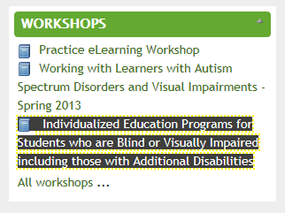

- Review the syllabus and rubric to familiarize yourself with the expectations of the workshop. New assignments will open weekly; Lesson One will be available Friday, Month dd^{th}.

- Confirm your accessibility needs. You may have been asked in the registration process whether you need any accommodations to access the materials in this workshop. If you have not yet communicated your needs to our office, please contact Mary.zatta@perkins.org and [instructor] as soon as possible.

